**Explore digital game creation software, hardware and peripherals**

Peripherals are the various devices which you can connect to your computer. The main aim of them is to give you additional functionality and make it easier to use. Making games. You would need the following peripherals.

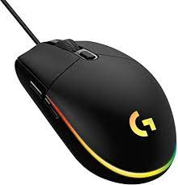**Mouse.** these used for creating games by clicking on things highlighting dragging scrolling and generally interacting with the software that you are using to test games with mouse. You will make sure that it did for you to hopes it would do when you made the game. For example, you would click on an item in the game and it would do something or you would use the mouse to look around. Generally in games might see used to aim and give her first person point of view, but can also be used to select items and characters in different types of games. The main benefit of a mouse is that they're very precise and very accurate, so it can be really good for using on a computer. This is advantages that are not really suitable for some games such as driving or flying games and you do need to have a flat surface for them to be used for efficiently.

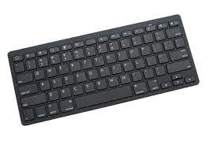**Keyboard.** This is used to create games by typing the code in to the computer. Without keyboard, it would be very hard to create code when you are testing games. You would check that the keys that you coded do certain things that your character did what they wanted them to do when you're playing games you generally use WAS and D to move. The character around forward backwards left and right. And then things like space for jump and R for reload etc. The main advantage of a keyboard is there are lots of different buttons so you can have lots of different commands in your games and lots of different combos disadvantages again that you don't need a flat surface to use it efficiently.

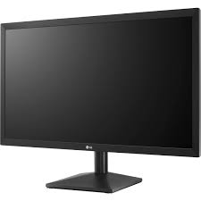**Monitors.** When you're making games you would use them on it to see the software. The bigger the money at the more you can see some people have dual monitors so you can have your game preview on screen and your code on the other and quickly make changes to see the effects. when you're playing games you would obviously want a big screen to make it more immersive. Games you would have to make sure that your game ran at the different resolutions that different people would have. For example, some people might have a 4K monitor and some people might only have a 720p screen so you'd have to check that your game looked good at all resolutions sometimes on a 4K screen text can look very small so you'd have to have some kind of additional enlarging of the text to make it easier to see.

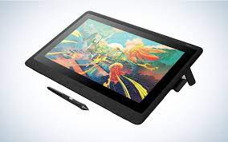**Graphics tablets.** can be used not to play games really, but are good for making games allowing you through your own graphics and create your own sprites.

**Game controllers**. are always good because they have wireless so you don't have to have a cable connected to your device and they have every button within easy reach of your hands. These are good because you don't need to have a flat surface to do it so you can sit on the sofa and play your games on the TV without having to be stuck in the desk like you would with a PC. Generally, they 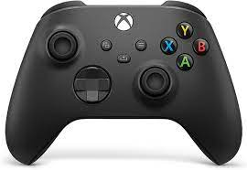have two thumb sticks and one is used for moving and one is used for aiming. Then they have trigger buttons and shoulder buttons as well as four main buttons. Depending on the game. They are quite good for driving games because they have analogue sticks. Meaning that the further you push the stick, the more input goes so you can use it like an accelerator. They ate not as good for some games that they're not as precise as a mouse can be.

In terms of hardware, you can play games on different devices. Each have pros and cons depending on how serious you want to take your gaming money you want to spend.

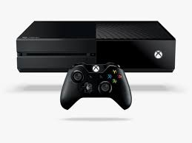Popular device is probably a **game's console** such as the Xbox or the PlayStation. These are computers designed for games so they're very well up optimized and they tend to have fast run times because they don't do all the other things that PC does that just focus on playing games these are pretty good for when you're testing games if you make a game on PlayStation, for example, you know that game will work on every PlayStation because they're all the same hardware inside this advantages of games consoles are that they don't have all the capacities of the PC and they have keyboard and mouse so some games aren't quite as good on a console as they would be on a PC. They also are harder to upgrade and you can only add a hard drive to them to give more storage. You couldn't, for example give more memory to it. You also have to buy the games for them which are more expensive. If you are making games for games consoles, you often have to have the license from either Sony, Nintendo or Microsoft to put your game on there, meaning that you might lose some revenue from your game.

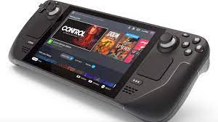**Portable games consoles** or another popular choice such as the steam deck. These are just like a games come so but they tend to have a screen in the middle of a control stick and run on batteries so you can take them with you. But this is the very swollen portable so you don't have to carry anything else with you. The disadvantage day is that they're not quite as powerful as I'm standard games console because they have to have smaller size and the batteries won't last forever. So you will have to keep charging them or carry spares with you.

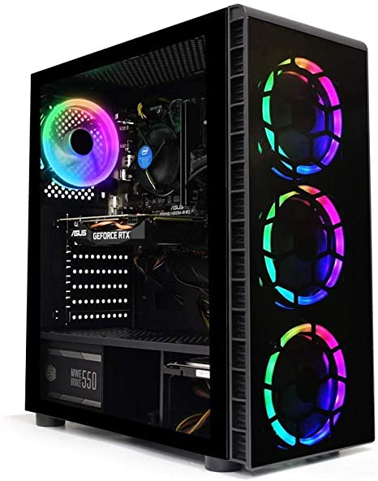**PC's** are the best way to play games because they have the most power and they have really powerful CPUs GPUs. You can have plenty of memory as well as connecting your own devices and peripherals to customize it to your own style. There is also a really big indie scene on PC what people can make their own games without having to get Microsoft or Sony involved so there's way more choice for games. If you're making games for PC though, you do have to make sure that your game will work on lots of different configuration because everyone else will have a different set up to you. So can we quite time consuming. The main disadvantage of a PC is the obviously you need to have a desk to put it on and they can be quite expensive to run because of the fast hardware inside them so electricity bill might go up.

**Software.**

We need to make a game it depends what type of game you're going to make. It could be a 2D game or 3D game and that will change the choice of software that you would use. It would also depend on how experienced you are if you're really good at coding and you could use something like **Unity** which is a very popular 3D software. It has lots of different features and can do full 3D rendering as well as physics and AI. You can make games for Windows, Max, Linux and both Apple and Android devices so you would have lots of show customers to play a game. However, it is quite difficult to learn and not the best. If you're just starting out, it also costs a lot. If you were going to make a full game, there is free version, but they charge for the full version of the software. Examples of games made in Unity are Fire Watch and Cuphead. Well that is a fully AAA games. They don't have the best graphics which is one of the problems with unity. It's good at doing kind of cartoon graphics but not really realistic graphics. https://www.tutorialspoint.com/unity/unity_introduction.htm

If you want something but easier to use you would use something like **construct 2**. I've used this before in school and it's quite easy to pick up. You don't really need any coating skills because it uses a dragon drop block base coding which allows you to quickly set up your game. You can then enter more complex code once you have things working which allows you to quickly test ideas. There's also allows you to make games for Windows, Mac clinics and Apple and Android, as well as making games that can run just on the website. There's quite a lot of tutorials and guides that you can get access on YouTube and on their own website. So if you get stuck you can find help quite quick. It's only really good for 2D. You can't do 3D games with it but have seen some demos where people have done a fake 3D which is quite cool but still looks a little basic compared to what you can do with proper 3D software. <https://subscription.packtpub.com/book/game> development/9781784397678/1/ch01lvl1sec08/about-construct-2

Other option for easy game making would be **scratch** which is really simple to use. It works a little bit like constructs with drag and drop blocks that fit together to form a hierarchy of code. It's mainly used for teaching pupils have to use code like I used and Year 7 to learn how to do computer code. It's very limited and usually you can only have games on one screen without much scrolling and the graphics are very simple, but it's a good way of doing it. The games made on this tend to be very simple like Tower defense games or little racing games, but it's a very good way to learn. https://scratch.mit.edu/about